ST. LEO’S AND SOUTHMEAD CATHOLIC NURSERY & PRIMARY SCHOOL
Head Teacher: Mrs A. Tambourini
Lickers Lane, Whiston, Knowsley L35 3SR
Telephone: 0151 477 8410
www.stleossouthmeadnursery.co.uk www.stleossouthmead.co.uk
stleo@knowsley.gov.uk
@stleossouthmead
Weekly Newsletter

Friday 14th September 2018
After School Activities  This evening, all children who have been signed up for after school clubs will receive a letter confirming which clubs they have been allocated. Thank you for supporting our extra-curricular activities, we were overwhelmed by the number of children who are enthusiastic about staying behind after school and widening their experiences!  Monday Choir with Miss Allen (KS2)  Tuesday: Cookery with Mrs Smith (KS2)  Tuesday: Reading and craft with Mrs Pimblett (KS1)  Tuesday: Sports with the coaches (KS1)  Thursday: Sports with the coaches (KS2)  Class Dojo  A huge thank you to those parents that have already signed up to Class Dojo! Teachers have informed me that the feedback so far has been very positive...long may it continue!!!  I have advised teachers to turn off the ‘portfolio’ side of the app for the time being. This is due to this feature being new, as yet few schools have advised on the benefits of it and I would like to ensure it is productive before encouraging our children to use it. | Attendance  I am sure you don’t need me to remind you that attendance is high priority for our school. Please work with us to ensure your child attends school every day and that they arrive by 8.55, but doors are open from 8.45. If your child is sick and cannot attend school, please call the office as early as possible so that we can let class teachers know. Once your child returns to school, please send in a note explaining the reason for their absence.  If you have booked a holiday during term time, it is important that you fill in a holiday form and return it to the school office. I must advise that no holidays can be authorised, however it does help us to identify where your child is when they do not attend school.  We are advised by the local authority to ‘locate’ every child who does not attend school.  If we are unable to locate a child they are officially classed as ‘missing’ and we have to report this to the correct authorities. So please…even though we cannot authorise any holidays….ensure you let us know if your child will be absent.  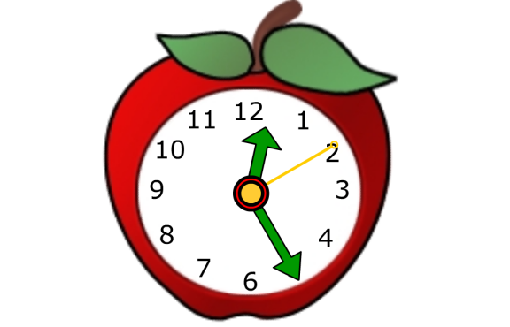
Coffee Mornings  Your child’s class teacher would like to invite you to a coffee morning in order for them to talk to you about the year head. Please look at the dates below and make a note of when your meeting is.  All meetings will take place in the school hall.  Monday 17th September – 230pm Year 1  Tuesday 18th September – 9am Year 2  Tuesday 18th September – 2.30pm Year 3  Thursday 20th September – 9am Year 4  Thursday 20th September – 2.30pm Year 5  Friday 21st September – 2.30pm Year 6  Cycle Training  This week, cycle training started for our Year 5 children. It was fabulous to see so many of the class joining in and making the most of this wonderful opportunity to improve their skills and be more safety aware when riding their bikes! The final session takes place next week where the children will complete an assessment of their road safety techniques or be given the opportunity to enhance their already growing skills.  Our Year 5 parents should keep an eye out for a letter inviting Year 5 children to ride to school on their bikes in future and leaving them in the bike sheds at the side of the junior yard!  A Very Special Visitor  Bishop Tom Williams is visiting our school next Friday, this is very exciting as he will spend the whole morning with the children and he will see what a wonderful school St Leo’s and Southmead is! I personally cannot wait to show off your children as they truly are the best! | Dinner Money  If you pay for your child to receive a school dinner, we ask that you bring dinner money in an envelope with your child’s name and class on. The daily cost for a school dinner is £1.90. We also have the parent pay online payment tool. If you need updated details of this, please contact the school office on 477-8410.  Twitter and Website  Our school is amazing…and I want the world to know it! I have updated our Website and Twitter accounts so that they are relevant to us. Please can all parents return the permission slips that went home at the start of the week allowing me to post pictures of the children being wonderful! I will never post a child’s full name on any of these sites, and pictures will be purely to celebrate the many successes we will see!  Be sure to sign up to Twitter and follow us!  @stleosandsouthmead  Good Work Awards  Well done to the following children for really shining this week – they have won the weekly ‘Good Work Award’ and have received certificates in our weekly celebration assembly:  Ariana A – Reception Class  Hollie S - Y1  Dacry M – Y2  Bradley M – Y3  Paddy P – Y4  Sophia H – Y5  Caitlin G – Y6

