ST. LEO’S AND SOUTHMEAD CATHOLIC NURSERY & PRIMARY SCHOOL
Head Teacher: Mrs A. Tambourini
Lickers Lane, Whiston, Knowsley L35 3SR
Telephone: 0151 477 8410
www.stleossouthmeadnursery.co.uk www.stleossouthmead.co.uk
stleo@knowsley.gov.uk
@stleossouthmead
Weekly Newsletter

Friday 21st September 2018
Harvest Festival  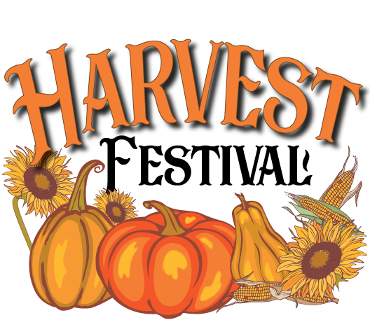  Next week is Harvest Festival – a time to think about the wonderful things that we have and also to consider those people less fortunate than us! On Friday I will holding a special ‘Harvest Festival Assembly’ and would like your help with this. I am asking all children to bring in 1item of food for us to put together as a donation for the local Food Bank. This can be anything at all – so long as it is not fresh food that has a short sell by date! Tins, packet foods, boxed foods etc are perfect! On Monday I will be taking one child from each class with me to deliver the food! Thank you in advance for your support with this valuable fund raising effort!  Bishop Tom’s Visit  Today we were visited by Bishop Tom. All of our children were introduced to him and he spent a lot of time talking to them and telling them how special and important they are. A very special well done has to be given to our year 2 children who invited Bishop Tom to their collective worship. Also to year 6 who asked some very interesting questions – Bishop Tom was very impressed with the thought that went into his time at our school! | Punctuality  I would like to remind parents that classroom doors open at 8.45am each morning. Teachers have work on desks ready for the children to begin their day and can support them if needed at this time. Classroom doors will be closed at 8.55am!  If your child arrives later than this they will have to walk round to the front office and sign in there. Being on time is an important life skill that will help your children as they grow older – please support us in our quest to get all children in school by 8.55am every day.  Parents Meetings  A huge thank you to all those parents that were able to attend our ‘meet the teacher’ sessions this week. Don’t worry if you missed it…class teachers have lots of information if you need a paper copy!  Dates for your Diary  There will now be ‘school nurse drop-in’ sessions on the first Wednesday of every month. This will start at 9am and is open to all parents who wish to attend. The first session is on Wednesday 3rd October.  Parents evening will be on Wednesday 17th October, more information will follow in a couple of weeks.

