ST. LEO’S AND SOUTHMEAD CATHOLIC NURSERY & PRIMARY SCHOOL
Head Teacher: Mrs A. Tambourini
Lickers Lane, Whiston, Knowsley L35 3SR
Telephone: 0151 477 8410
www.stleossouthmeadnursery.co.uk www.stleossouthmead.co.uk
stleo@knowsley.gov.uk
@stleossouthmead
Weekly Newsletter

Friday 7th December 2018
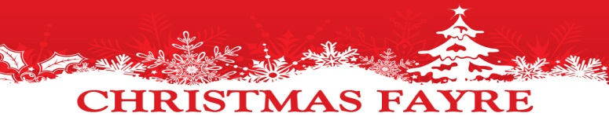  Our Christmas Fayre will take place next Friday – 14th December. I would like to thank all of you who have donated so generously, already we can see that next week will be a huge success!!!!!  Please continue to have a sort out and send in any items that you feel will be useful to us. And don’t forget…the fayre starts at 3.15pm and EVERYBODY is welcome…including nans, grandads, aunts and uncles!  Our wonderfully talented children!  We have lots of talented children here at St Leo’s and Southmead, as well as lots of talented parents! We would like to say a huge well done to Lauren in Year 3 for creating a beautiful Christmas portrait that won a nationwide competition for the charity ‘mind.’  Isabella in Year 4 has been preparing to perform in the St Helens theatre production of ‘Peter Pan’ which starts tomorrow. She has been rehearsing every day for this show and has proven to be a very dedicated performer. Well done Isabella!  We like nothing more than to celebrate the successes of our children…please do not hesitate to let us know if your child has done something special outside of school so that we can share their good news with the rest of the school community.  Pantomime and Breakfast with Santa  A letter has been sent home about these events…please be sure to return the slips as soon as possible! | Dates for your Diary  12/12/18 Cathedral visit – Y4  13/12/14 Christmas jumper day  13/12/18 Christmas dinner  14/12/18 Christmas Fayre  17/12/18 Whole school Pantomime visit - pm  17/12/18 Nursery & Reception Christmas play: 10am  18/12/18 Nursery & Reception Christmas play: 10am  19/12/18 Breakfast with Santa  19/12/18 Christmas Parties  20/12/18 KS1 Christmas play: 9.30am & 2pm  21/12/18 KS2 Carol service 10am in Church  21/12/18 1:30pm Finish!  07/01/19 Return to school  Christmas Performances  Christmas performances will take place over the next few weeks. Our Nursery, Reception, and years 1 and 2 plays will all take place in the school hall. Due to the number of children taking part, we will have to limit the number of tickets per performance to 3 per child. These tickets will be sent home with your child…if you do not need all of your tickets, we kindly ask that you bring them back into school so that we can give them to other parents who may need more.  The KS2 carol concert and Nativity will take place in St Leo’s Church on the final day of term at 10am. Father Michael is looking forward to welcoming children and parents for this very special event.

