ST. LEO’S AND SOUTHMEAD CATHOLIC NURSERY & PRIMARY SCHOOL
Head Teacher: Mrs A. Tambourini
Lickers Lane, Whiston, Knowsley L35 3SR
Telephone: 0151 477 8410
www.stleossouthmeadnursery.co.uk www.stleossouthmead.co.uk
stleo@knowsley.gov.uk
Weekly Newsletter

Friday 7th September 2018
Welcome  I would like to welcome you to the first weekly newsletter of this school year. Please take the time to read these newsletters as they will be packed full of information about what has been happening in our school over the course of the week as well as information about future events.  It is intended that the weekly newsletter will replace most letters that go out to carers parents each week, reducing the amount of paper sent home as well as having all information in one place – making it easier to keep track of.  I do hope that you find these weekly updates useful and that you look forward to reading them!  After School Activities  We are delighted to be offering a variety of after school activities for or children throughout the course of the year. All cubs will run from 3.15pm an finish at 4pm. This term the following clubs are available:  Monday Choir with Miss Allen (KS2)  Tuesday: Cookery with Mrs Smith (KS2)  Tuesday: Reading and craft with Mrs Pimblett (KS1)  Tuesday: Sports with the coaches (KS1)  Thursday: Sports with the coaches (KS2)  Please see the attached sheet with further details on how to book your child onto the clubs. | Attendance  I am sure you don’t need me to remind you that attendance is high priority for our school. Please work with us to ensure your child attends school every day and that they arrive by 8.55, but doors are open from 8.45. If your child is sick and cannot attend school, please call the office as early as possible so that we can let class teachers know. Once your child returns to school, please send in a note explaining the reason for their absence.  If you have booked a holiday during term time, it is important that you fill in a holiday form and return it to the school office. I must advise that no holidays can be authorised, however it does help us to identify where your child is when they do not attend school.  We are advised by the local authority to ‘locate’ every child who does not attend school.  If we are unable to locate a child they are officially classed as ‘missing’ and we have to report this to the correct authorities. So please…even though we cannot authorise any holidays….ensure you let us know if your child will be absent.  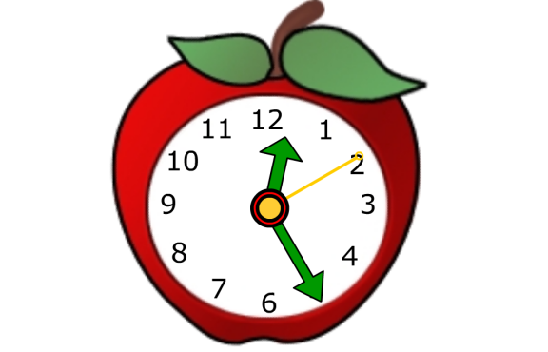
Contact Information  Next week, we will be sending home a new contact information form for all parents to complete. Please fill it in with your up to date details and return to us as soon as possible so that we can update the system.  Class Dojo  Every class will be getting Class Dojo this year. This is a wonderful programme which has two purposes:  1 – a reward system to be used in class  2 – a form of communication between parents and teachers.  Every parent will receive a letter explaining in more detail what Class Dojo is all about and how it can give you a better insight into your child’s education.  When you receive your login details, please download the app to your phone or device and follow the instructions. Please note that Class Dojo is a ‘parent app’ and should not be given to children to use due to it being a means of communication between you and your child’s class teacher.  I have personally used this programme both as a teacher and as a parent and can honestly say that it is a fantastic tool! There is a messaging option on the programme that allows you to contact the class teacher directly; please be mindful messages may not be seen straight away! Also, we do ask that you only message a reasonable times - not late at night or weekends.  I look forward to hearing your feedback about this programme – although I am certain you will love it as much as I do! | Coffee Mornings  Your child’s class teacher would like to invite you to a coffee morning in order for them to talk to you about the year head. Please look at the dates below and make a note of when your meeting is.  All meetings will take place in the school hall.  Monday 17th September – 230pm Year 1  Tuesday 18th September – 9am Year 2  Tuesday 18th September – 2.30pm Year 3  Thursday 20th September – 9am Year 4  Thursday 20th September – 2.30pm Year 5  Friday 21st September – 2.30pm Year 6  Dinner Money  If you pay for your child to receive a school dinner, we ask that you bring dinner money in an envelope with your child’s name and class on. The daily cost for a school dinner is £1.90. We also have the parent pay online payment tool. If you need updated details of this, please contact the school office on 477-8410.  Pupil Premium  All children in KS1 (reception, Y1, Y2) are entitled to a school meal provided free of charge by the school.  Pupil Premium Funding is paid directly to the school to enable us to better support the children in our school. However, this funding is based on the number of our families who apply for free school meals – even those children in the infants!!!! Please, if you are on any benefits at all, please complete a form which can be collected from the school office.

