Year | 2018/19 | 2019/20 | 2020/21
Autumn | Christian Living Theme  Advent/Christmas  ̴ Loving | Church Theme  Domestic Church  ̴ Family | Sacramental Theme  Baptism/Confirmation  ̴ Belonging
Spring | Church Theme  Local Church  ̴ Community | Sacramental Theme  Eucharist  ̴ Relating | Christian Living Theme  Lent/Easter  ̴ Giving
Summer | Sacramental Theme  Inter-relating  ̴ Reconciliation | Christian Living Theme  Pentecost  ̴ Serving | Church Theme  Universal Church  ̴ World
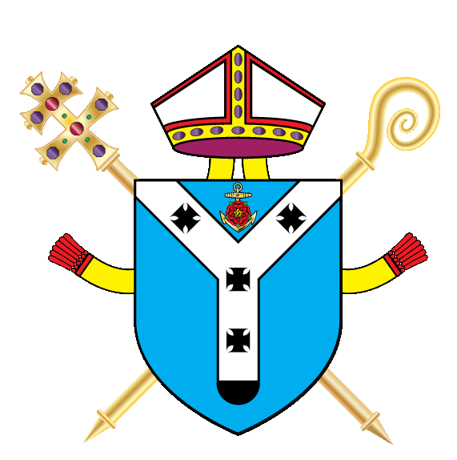
3 Year Formal Assessment Planner

