 | 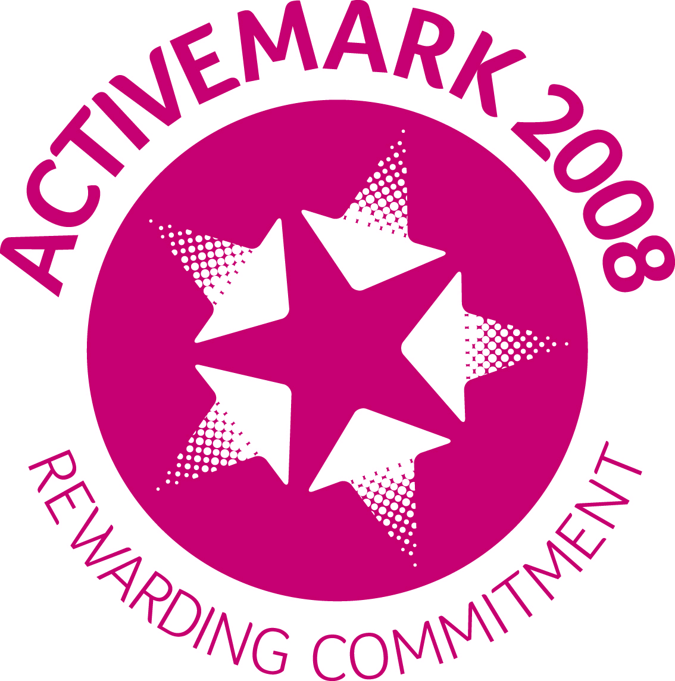 | ST. LEO’S AND SOUTHMEAD CATHOLIC NURSERY AND PRIMARY SCHOOL SERVING THE COMMUNITY LICKERS LANE, WHISTON, KNOWSLEY L35 3SR  Head Teacher: Mrs A. Tambourini Telephone: 0151 477 8410  www.stleossouthmeadnursery.co.uk www.stleossouthmead.co.uk  stleo@knowsley.gov.uk
“Nurture, Inspire, Succeed”

19th May 2020
Dear Parents and Carers,
I hope you and your families are still well and healthy and the children are all still smiling.
Schools reopening
The focus of my letter today is regarding the government announcement last Sunday about schools reopening in June. Throughout the past ten days, there has been a large amount of guidance from the DFE which we, as a school, have been trying to use in order to come up with a safe plan to reopen to the year groups suggested. Government guidance may change again over the next few days and we may have to rethink plans again. Knowsley Council have issued the following statement:
‘The top priority is for schools to re-open safely rather than quickly, or on any given day.’ The full article can be found following this link: https://www.knowsleynews.co.uk/reopening-schools-in-knowsley/ .
I can confirm that our earliest date of opening will be Monday 8th June in line with our scheduled Whit Holidays. However we will not be opening for all children, we will be adhering to government priority groupings.
Priority Groups
The government have made it clear that we should prioritise children in the following order:
- Children of key workers
- Vulnerable children (EHCP or Social Worker)
- Nursery
- Reception
- Year 1
- Year 6

Group 1 and 2 - Children of key workers and vulnerable children
As you can see, priority group 1 and 2 are key workers and vulnerable children. Potentially, at least 30% of our children fall into this category. We have measured all of our classrooms and can safely accept a maximum of 76 children in order to keep to social distancing and guidelines. If all children in category’s 1 and 2 wish to return, I would be unable to offer places to any other year groups. I may also need to prioritise need in this group with the first places given to families who have 2 critical key worker parents. These children would attend school every day and remain in a mixed age group. After I have a definite number of children in this group, I will then look at the need in Nursery and then move up through the other year groups.
Groups 3 - 6
Although the government guidance states 15 children to a room, I do not feel that this is in any way safe for our youngest children. Therefore, year groups will be split so that we can have smaller numbers in each room and staff will be able to work on a much more individual level and support your children safely. This means that not all children in each year group will be able to come into school at the same time and will not be in every day.
You should be aware that because we need to reduce contact between groups, children cannot move between the key worker group and their own year group. Children may not be in their usual classroom or with their usual teachers. Please consider this when you make your decisions.
Staggered Starts and Wrap-Around Care
As children must remain in their own group, including teachers and teaching assistants, we will be unable to offer Breakfast Club to any of our children. We will also need to have staggered start and finish times for each group to minimise contact at the school gate. The George Howard Community Centre car park will also be closed, meaning there will be no parking facilities leading to the school. Parents will be required to either walk to school or park and walk in order to keep the road leading to school clear for the safety of all children. I can also confirm that parents will not be allowed on the school site, instead you will be asked to wait 2 metres apart outside the school for drop off and pick up. Staff members leading each group will collect the children from the school gate at their allocated drop off and pick up times. More detail around this will be communicated once we know numbers of children attending.
Non-Attendance
If you decide not to send your child back to school, there will be no penalty and we will endeavour to continue setting home learning.
Health and Safety
Whenever and however we reopen, we will do our very best to keep your children safe and we have numerous dynamic risk assessments and procedures to help us to do this. While we will do our utmost to ensure the children remain in small groups, wash their hands regularly and have staff cleaning the classrooms and equipment throughout the day, I cannot promise that they will always remain 2 metres apart and do not touch something that another child has touched before we can clean it.

Booking a Place
If you fall into Groups 1 and 2 and would like to request a place, please email the school directly with the following information :-
Childs name, year group, your name, key worker role for all parent/carers living at home, place of employment.
Vulnerable children need not include this information but still need to email school if they wish to use their place.

If you fall into Groups 3 to 6 please email with your child’s name and year group if you would like to use a place.
School email address : stleo@knowsley.gov.uk
Please return all emails by Friday 22nd May 2020 at the very latest.
Any emails after this date may not be considered for a place as allocations will have already have been made.

I appreciate that this is a lot of information to take in and I understand that you may have lots of questions. I will aim to give you more details about our plans next week and will be available if you wish to call school.
Thank you for all of the support you have shown our school over the past weeks. We are so lucky to have such a wonderful school community who work together and appreciate each other.
Kindest regards,
Mrs A Tambourini
Headteacher

