 | 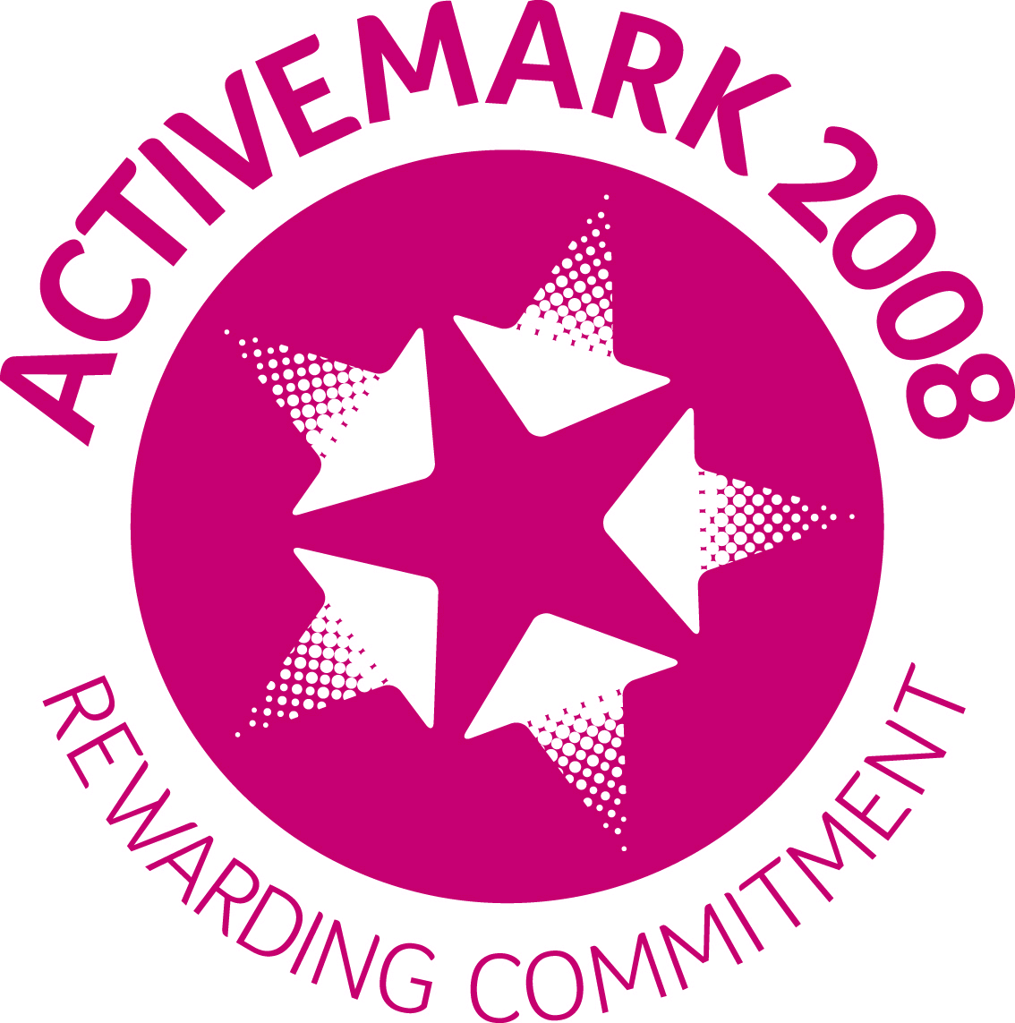  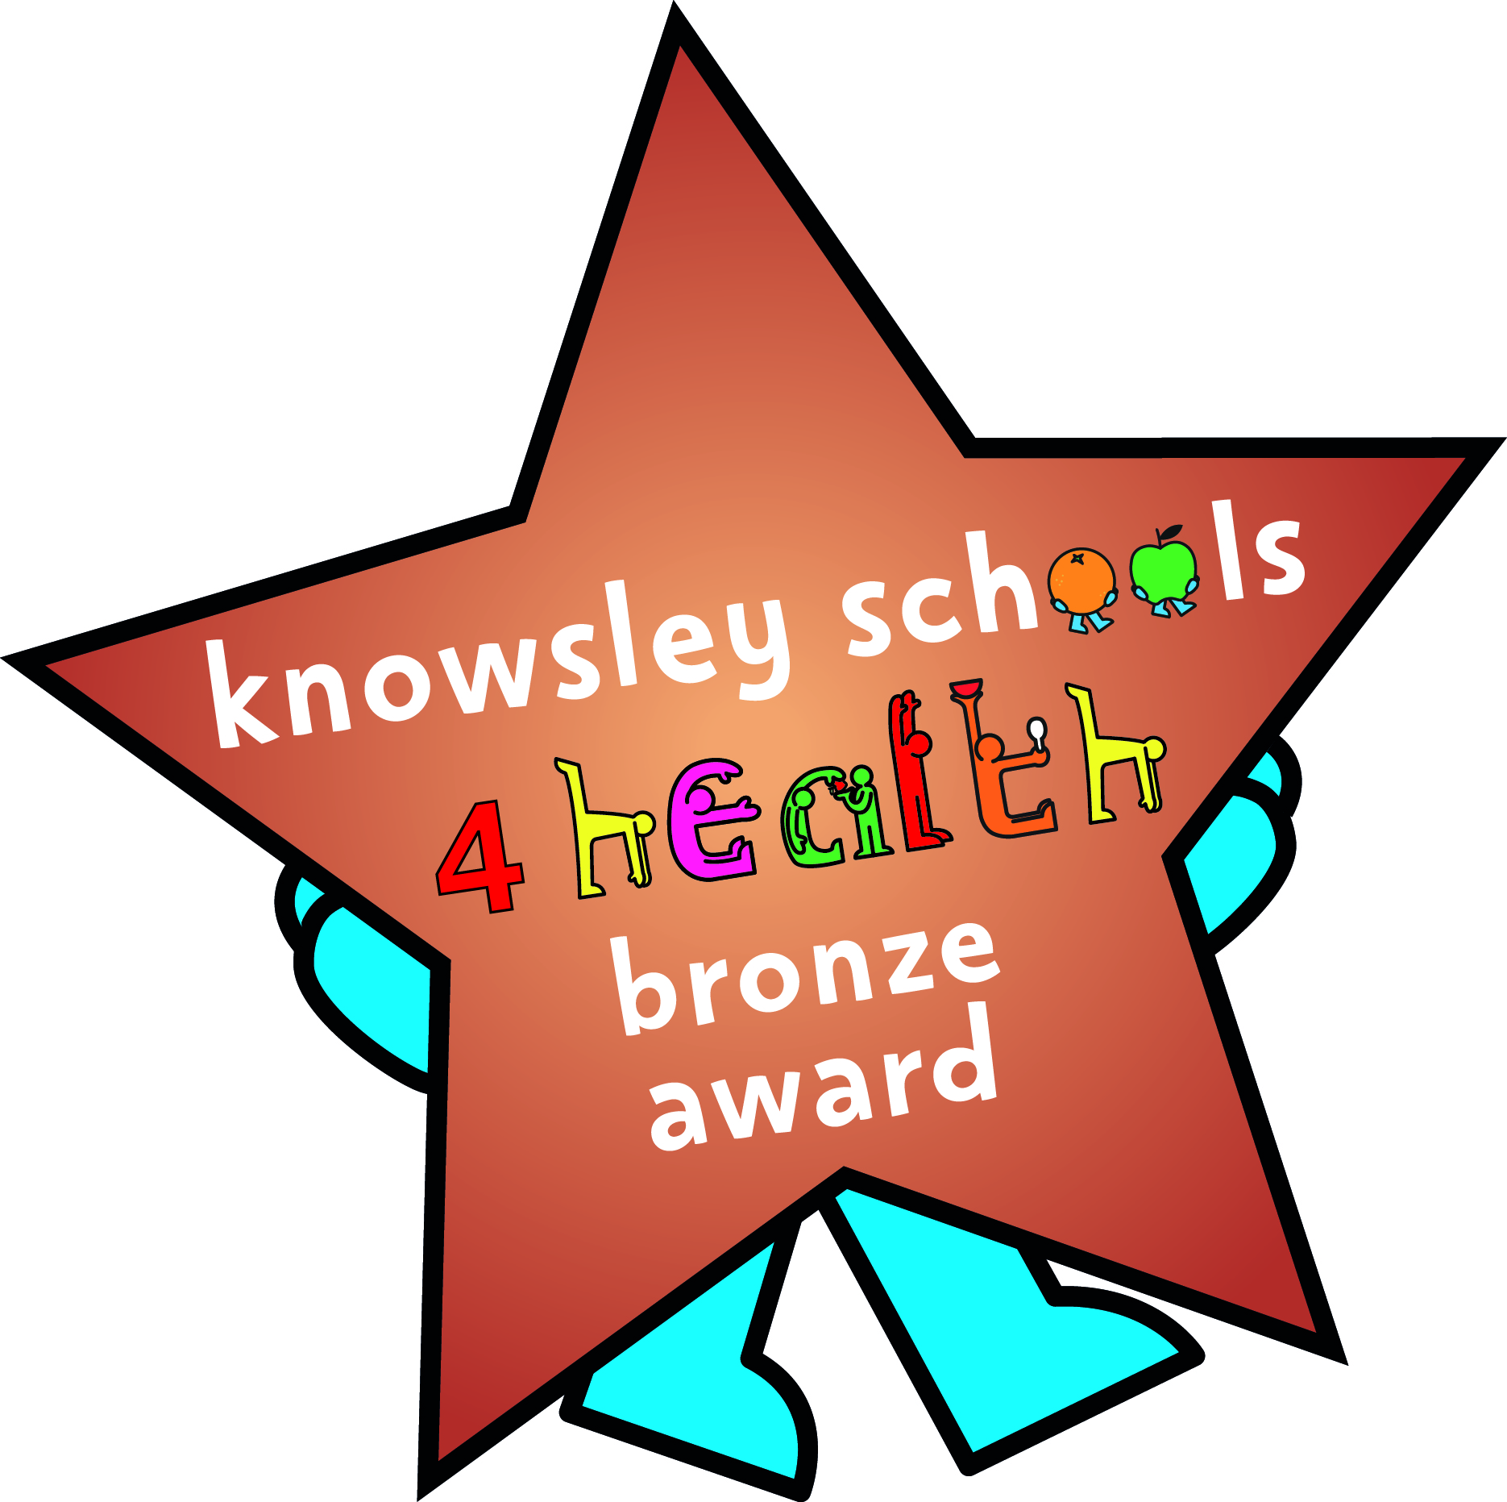 |  |  | 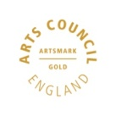 | 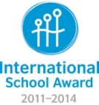
ST. LEO’S AND SOUTHMEAD CATHOLIC NURSERY AND PRIMARY SCHOOL
SERVING THE COMMUNITY
LICKERS LANE
WHISTON
KNOWSLEY L35 3SR
Head Teacher: Mrs A Tambourine Telephone: 0151 477 8410
www.stleossouthmeadnursery.co.uk
www.stleossouthmead.co.uk
stleo@knowsley.gov.uk
September 2020
Dear Parents/Carers
My name is Mrs McGuinness, and I’m your child’s class teacher and Mrs Sinclair is the Year 2’s Teaching Assistant. I am really excited that I will be teaching your child this year. I hope you have managed to have an enjoyable summer and have spent some quality time with your child, despite the difficult circumstances. I understand that many of you will be feeling anxious about the children returning to school, but please let me reassure you that all of the necessary risk assessments and safety procedures have been implemented and the children’s safety and well-being is our main priority. Here is some information about the coming year that will hopefully inform you of the important things you will need to be aware of. Please do not hesitate to contact myself or school, either via dojo, phone call or email, if you have any further questions. If you would like to speak about your child at any point at all during the year, please just telephone the school office to make an appointment with me, you do not have to wait until parents evening.
Year 2 is an exciting year in which your child will make lots of happy memories and learn new skills in all areas. The Year Two web page on the school website and the Year Two class Dojo will be used to give you information and to share photographs and celebrate the children’s work. Look out for important dates and information in newsletters and on the website. I will put reminders on the class dojo as this is a direct way to share messages.
Attendance
As part of our ‘Enjoy and Achieve’ we celebrate attendance with rewards and prizes weekly in class and in assembly every Monday. Attendance is celebrated each week on the school newsletter and on the school website. I would love Year Two to be the best attending class in school and I’m sure this is something we can achieve. If your child feels a little unwell in the morning, please still bring your child to school and if we need to phone you as they become to unwell to stay with us we will do so straight away.
It is so important that your child attends school every day but sadly there are times when they are sick and unable to come in. If your child is sick you must phone school that day between 8.30am and 9.30am. If we have not received a call by 9.30am a member of staff will give you a courtesy call. When your child is well enough to return to school please write a letter upon your child’s return explaining the reasons for absence. This is in line with the attendance and inclusion service of Knowsley Local Authority.
We strive at St. Leo’s and Southmead for every child to be happy and that their voice is heard. Help and support is available within school if you feel there are any difficulties in your child attending regularly.
Punctuality
Please make sure that your child arrives at school on time, the children will be collected from the Junior playground from the designated Year Two area at 8.45am by myself or Mrs Sinclair. Learning starts each day the minute your child sets foot into the classroom. Sadly children can become upset if they arrive late and are unsure what they are to do. Arriving each day on time is an important life skill which can help with both your child’s progress and self confidence. We are asking that the children be collected from the Junior playground at 3 o’clock in order to maintain health and safety measures outlined within the school risk assessment to ensure social distances.
Dates for your Diary
Dates for the coming school year will be available soon, keep an eye on the weekly newsletter. In order to help you and give you as much notice as possible these are provided in news letters, class dojo and on the school website.
Water
It has been scientifically proven that children that have constant access to plain still water improve their learning in class each day. Please can I ask you to provide your child with a water bottle with their full name written on. Please do not send in juice or flavoured water as it ruins tables, carpets, floors and children’s books. If your child’s water becomes warm we will empty the bottles and refill them with cold water. The children will be encouraged to drink water throughout each day in class. Each night the children will bring their bottle home to be refilled with fresh plain water ready for the next day.
Bagels
The children in Year Two can have a warm bagel each morning when they arrive in school.
Playtime Snacks
If you would like to provide your child with a healthy snack each day this might be a piece of fruit, bread sticks, crackers. As we are a healthy school we ask the children do not bring crisps, biscuits or chocolate for break times. Each day the children will have warm bagels at the start of the day and then milk and fruit in class.
Money and messages
Please ensure that all money is put in envelopes marked with your child’s name and what the money is for. Please do not hand me money at the door as it can be confusing who has given me what and what for. Can I also ask you to use class dojo to send any messages as verbal messages can often be forgotten and are not always suitable for the other children to hear.

Assessment and Tests
Year Two and Year Six are the two Year groups in which Children in Primary Schools throughout England complete SATS tests and assessments produced by the Government. Please do not worry about these tests. The children do not know they are tested as in Year Two the work the children do each week is used alongside tests and assessment activities, to determine the stage in which your child is working at. This is an important year for your child and there will be an informal meeting in the school hall to explain the changes to the SATs for Year Two and hopefully remove any worries you may have about SATs. This will be held later in the year and I will send the date to you nearer the time. Throughout the year and during the meeting I will explain lots of ways in which you can help your child, ideas and suggestions and resources will be given throughout the year.
Please do not worry about SATS in Year Two they are used as a way in which to show how your child is making progress in school. A copy of your child’s results will be sent to you with your child’s school report in July. If at any time you feel you would like to know more about SATS or your child’s progress please come and arrange a time in which we can meet. Assessment activities will be carried out throughout the school year, therefore attendance has an impact. The Year Two SATS must be completed during the month of May and therefore it is essential that your child is in throughout May. Please do not book any holidays during term time or during May as every day is important and work completed goes towards their SATs result.
This year following the decision by the Government to close schools the Year One Phonic screening test was cancelled. I know both the children and Mrs Pimblett had been working very hard to prepare for this test . All schools were informed in July that the children starting in Year Two were to sit the Year One Phonic screening test in the Autumn term before Christmas. The children will therefore be exploring lots of fun activities in class to prepare for this. I will also be sharing more information about the test and activities to explore at home with your child once the children have settled into the class.
Reading and Writing
Both Reading and Writing are important life skills. Reading and Writing skills are developed daily throughout the curriculum in Year Two. Throughout the year your child will be invited to take part in a variety of fun and exciting reading challenges all of which are planned to develop your child’s reading ability. Each child will be invited to change their reading book three times a week. Reading Books can be changed on a Monday, Wednesday and Friday. There are times when your child may choose a book or I may choose a book they have previously read. Should this happen this is a wonderful chance to celebrate with your child the progress they have made since they last read the book. In Year Two we use a range of books from a wide range of authors and schemes to ensure the children have opportunity to read books which help them to practise important reading skills outlined for Year Two.
Throughout the year the children will take part in many exciting themed activities from pirates to space all of which are planned to make writing for different reasons fun and exciting. Ideas and suggestions will be given throughout the year of ways in which you can help your child develop their writing skills.
Maths
Maths forms a life skill used daily. In Year Two the children will learn their two, three, five, ten and four times tables. The children will use Times Table Rockstars to practise their tables daily in school alongside games and other activities.

Uniform
Please ensure your child has the correct uniform. This includes plain black shoes. It is really important your child has their name in everything including their coat. Their school uniform is a reflection on the class, especially when we are out of school or when we have visitors into the classroom. Please ensure your child has a coat or rain jacket in school every day as the weather is very unpredictable and it enables the children to get some fresh air whatever the weather.
P.E.
P.E. is a compulsory lesson just like English and Maths, that your child must take part in. Your child’s P.E. lessons are on a Friday. Please make sure your child comes to school wearing their full PE kit (plain black shorts, White T-shirt and black pumps – with their name on everything. They can wear jogging/tracksuit bottoms on colder days as P.E. lessons will be outside as much as possible.
Spellings
Your child will be sent home every half term with a list of spellings a copy of the spellings is also on the website and will be posted on the Class Dojo. Your child will have a spelling test every Friday, but this is not something your child needs to worry about. Each week the children will practise their spellings throughout the week in class. Please help your child practise their spellings each week at home as this will help your child develop a skill which help them in both school and as they grow older.
Class Curriculum Map
A copy of the Year Two curriculum map is on dojo and has been added onto the Year Two page on the schools website. This shows you the topics that your child will be learning about throughout the year and helpful hints of ways you can help your child at home.
Homework
As explained in the welcome letter by Mrs Tambourini this year we are changing the way we offer your child homework to practise their skill s and use their learning at home. I will talk with you at the SATs meeting about ways in which you can help your child at home and if you would like to meet to discuss ways and activities to explore at home I am happy to make a time and meet with you to talk about activities that would help your child.
In addition each week the children will take part in a weekly spelling test on a Friday. Please help your child learn their weekly spellings.
Birthday Cakes
If you would like to send a small treat into class to celebrate your child’s birthday when it is their birthday can I suggest either a small packet of individually wrapped sweets or the packets of small fairy cakes as these are a much easier and cheaper option to share in school with their friends. Please do not feel that you have to send in a treat as we will always sing happy birthday to each child on their special day and make sure they have a lovely day.
Tissues
If possible can I ask that each child has a small packet of tissues which they can keep in their tray. I have given each of the children a small packet for their tray and we do have boxes of tissues in class for the children to use but it is much easier if the children have tissues in their tray to catch any sneezes or to blow their noses rather than travel across the room to collect one.

I’m really looking forward to teaching your child this year and working together with you to create lots of happy memories.
Thank you
Mrs McGuinness and Mrs Sinclair

