Fabulous fruit salad take home letter
Why not try a new fruit with your child each week? Have a look around a shop, market or supermarket for a fruit you haven’t tried before. Find out how it is prepared and try it with your child. Remember, your child will be watching how you behave with new food so keep the experience positive.
Here are some ideas of fruit you could try if you haven’t tasted them before:
- Damson
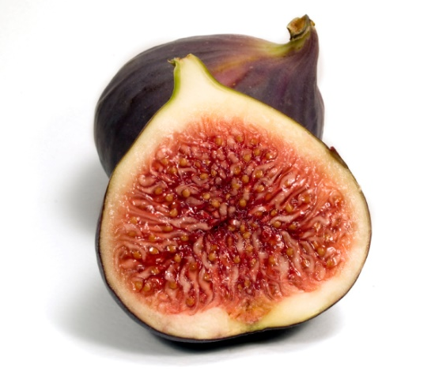
- Pear
- Gooseberry
- Blackberry
- Mango
- Pomegranate
- Star fruit
- Sharon fruit
- Chinese pear
- Watermelon
- Blood orange
- Dragon fruit
- Kumquat
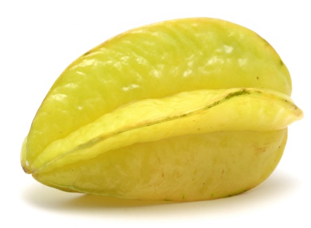
- Fig
