Fabulous fruit salad
Ingredients
2 satsumas
Complexity: low-medium
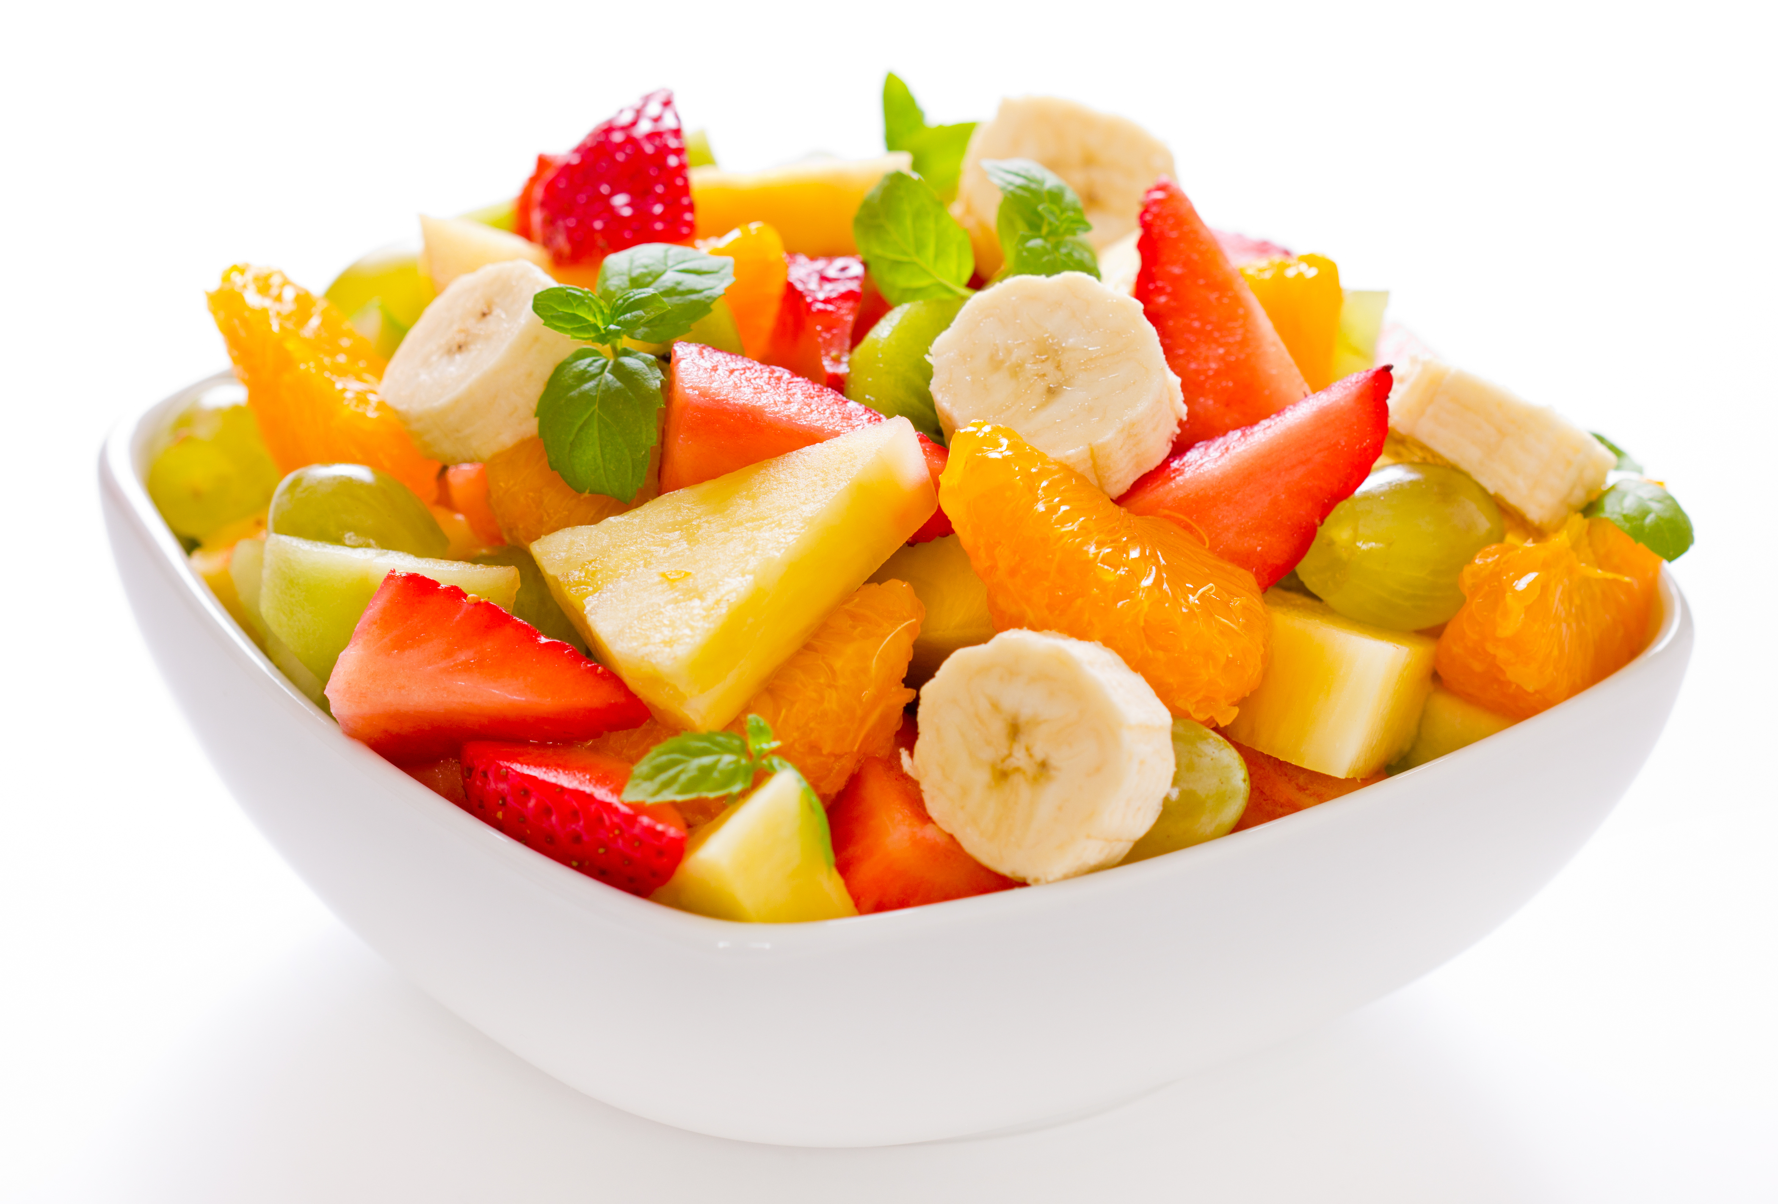
4 strawberries
8 seedless red grapes, halved lengthways
8 seedless white grapes, halved lengthways
2 bananas
2 x 15ml spoons orange juice

Equipment
Chopping board, table knife, large bowl, a 15ml spoon, 4 serving bowls.

Method
- Peel the satsumas and separate into segments.
- Pull the stalks from the strawberries and cut into slices.
- Peel the bananas and cut into slices.
- Place all the fruit in the bowl and add orange juice.
- Mix all the ingredients together.

Top tips
- Try using different types of fruit such as peeled and sliced kiwi fruit, chunks of fresh mango or canned pineapple.
- Instead of orange juice try another juice, such as apple.
- You could serve your fruit salad in a hollowed out fruit such as melon to make it look attractive.

Food skills
- Measure.
- Peel.
- Slice.
- Combine and mix.

