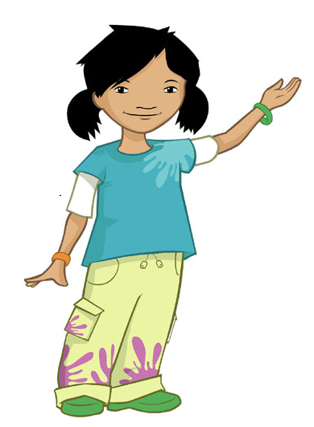

**Tie back long hair**

**What do we need to do before we cook?**

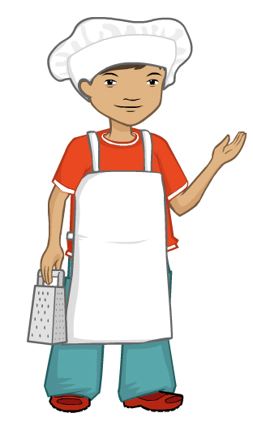

**Roll up long sleeves**



**Take jewellery off**

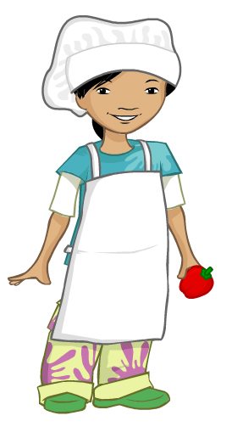

**Put on an apron**





**Wash and dry hands**