Pleasing Pasta
Next time you go food shopping, look out for different types of pasta with your child. Become a food investigator, and see if you can spot the types of pasta below. Tick off each type when you find it.
Pasta search!

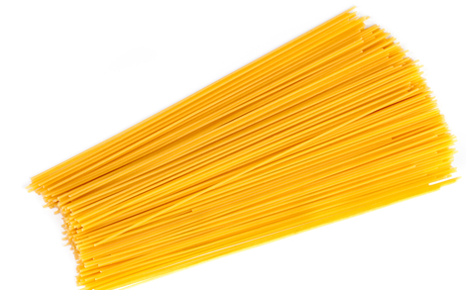
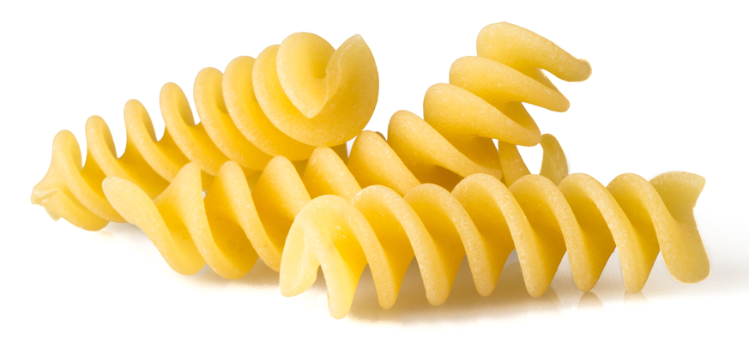

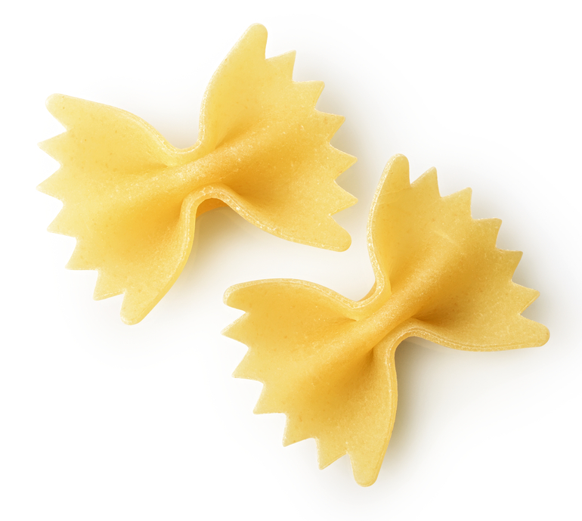
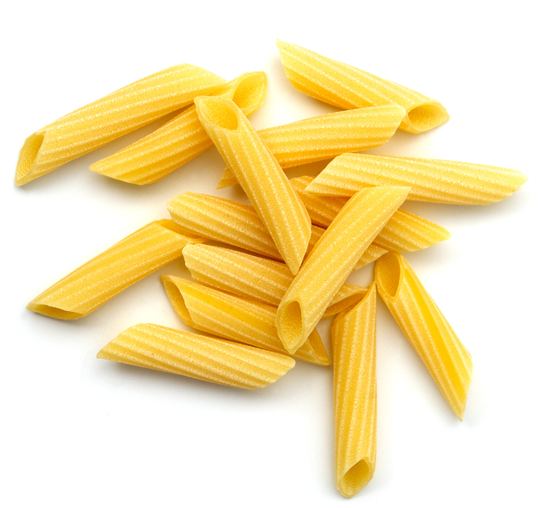
Fusilli
Spaghetti
Farfalle
Penne

