 | 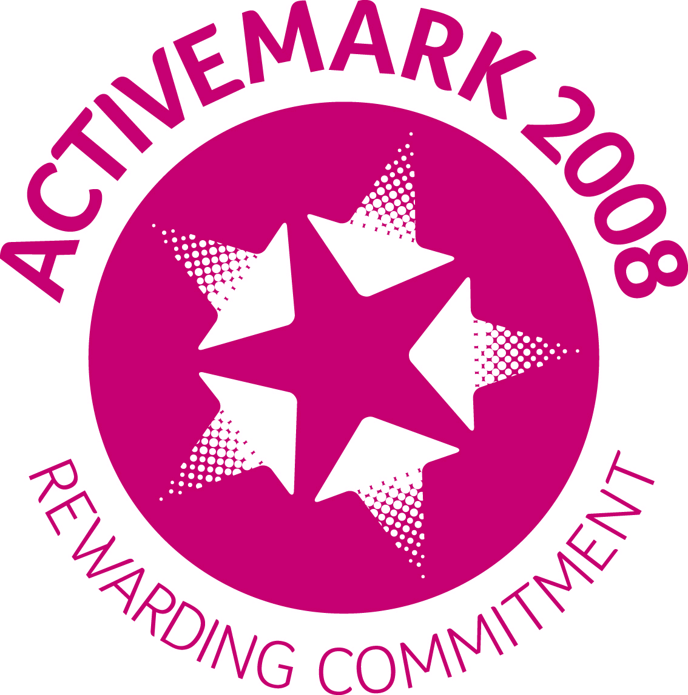 | ST. LEO’S AND SOUTHMEAD CATHOLIC NURSERY AND PRIMARY SCHOOL SERVING THE COMMUNITY LICKERS LANE, WHISTON, KNOWSLEY L35 3SR Head Teacher: Mrs A. Tambourini Telephone: 0151 477 8410 www.stleossouthmeadnursery.co.uk www.stleossouthmead.co.uk stleo@knowsley.gov.uk
“Nurture, Inspire, Succeed”

Wednesday 9th September 2020

For the Parent/Guardian of ______________________________ Year _____________
I am writing to inform you that your child has been offered a place at Breakfast Club. As you are aware, we have had to make some changes to the way that we run this provision in light of Social Distancing Requirements. However, we have worked incredibly hard to ensure that our children are safe and that we can still maintain our ‘bubbles.’
From Monday the new format for Breakfast Club is as follows:
- The school gates will open at 8am and stay open for 10 minutes. All children should come in before the gates close again as there will be nobody in the office to hear you if you are late and ring the bell.
- Your offer of a place is for 5 days. If you do not need the 5 days you do not have to bring your child in if you do not want to, however your place will remain available in the event that you do need it.
- The new cost for Breakfast Club is £7 for the 5 days, this is a set price for all parents even if you are not in every day. There is no daily price any more! I appreciate that this is an increase in price, however we have completed our research and are confident that we are still much cheaper than most other breakfast club facilities. Payment should be made in advance on the first day of week.
- For families of 3 or more children….if you use the facility for all children we will cap your cost at £15 per week.
Breakfast Club will now be led by Mrs Parker with the support of Mrs Lyon and Miss Moss. If you have any questions, please do not hesitate to contact us!
Yours Sincerely
Mrs Tambourini

